Step 1 . Week 2

1.Research how to create a hidden file and how to display it using ls command.

to create a hidden file we use: touch filename

To display hidden files we use ls -a

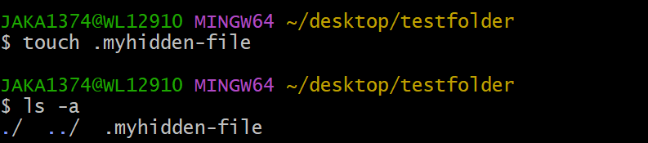

2. Research how to create multiple nested directories with one mkdir command.

E.g. How would you create 'fun' directory along with all directories in the path below:

/c/Users/unmesh/these/folders/are/just/for/fun

In this case we use :

mkdir -p /c/Users/unmesh/these/folders/are/just/for/fun

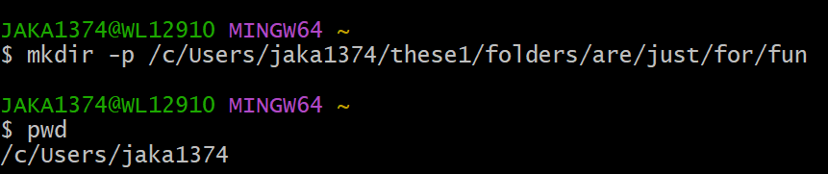

3. Execute following commands terminal:

echo "test" > fun

echo "another test" >> fun

wc -c fun

4. Research how to append something in the file \*WITHOUT\* a newline character.

